**Predict Future User Adoption by Identifying Affect Factors**

Hua Mo

Background

Relax Inc is developing a project management software to predict the potential “adopted” users to manage different project. As the first step, they would like to get the factors to affect ‘adopted’ users. The purpose of this project is to help them identify these factors.

Methodology

The method is to find the potential ‘adopted’ user through the user engagement database (takehome_user_engagement.csv). We will find “adopted” user by selecting any sign in 3-days differences less than 7days. Then join the dataframe with user information (takehome_users.csv). Assign the ‘adopted’ user with “1”, non adopted user with “0”. Use heatmap to see the features relationship with ‘adopted’ user. If the relationship of a factor was less than 0.01, that factor would not be considered as significant. Since the heatmap could only describe the relationship between numbers, we would also evaluate non-numeric features by pandas group method.

Results and Discussion

Results showed that factors: org_id, invisted by other user, the difference between last day to sign-in vs. creation time were the key factors to affect ‘adopted’ users because they both above 0.01. Creation source was another factor to affect ‘adopted’ user. Therefore, we suggest put these parameters in the prediction model. (cf. Fig.1)

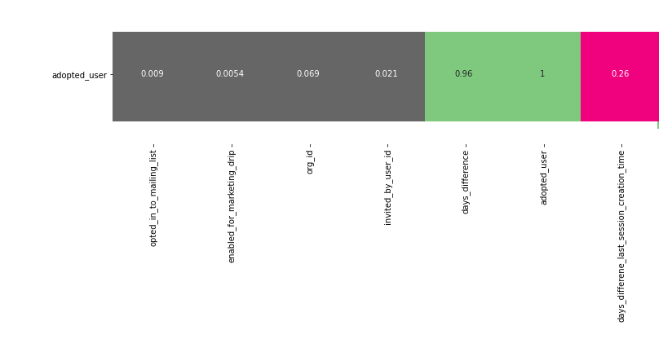

Fig. 1 Heatmap of Different Factor vs. ‘Adopted’ User